WHOLE SCHOOL SUBJECT OVERVIEW
SUBJECT: PE SUBJECT LEADER: Mrs Firth (supported by Mr Smith)
Wombwell Park Street Primary School- EYFS Physical Education
EYFS - Autumn 1
 | Nursery | Reception
Theme for learning/core books/rhymes and experiences | Marvellous Me  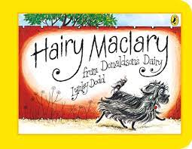  Humpty Dumpty | Marvellous Me  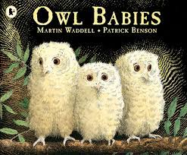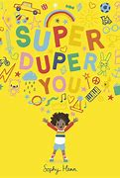
Suggested books linked to theme | 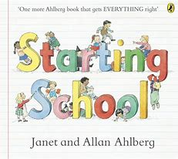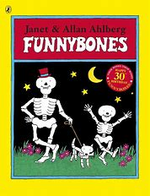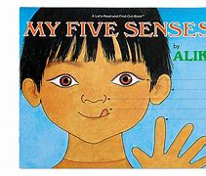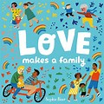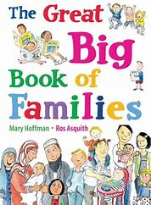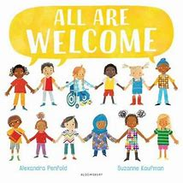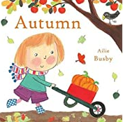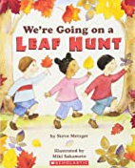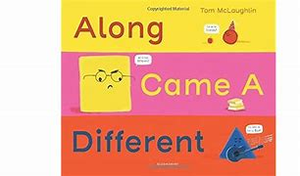
Theme days/ celebrations | 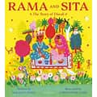  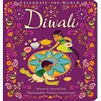  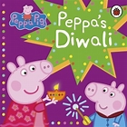  Diwali  I know that Diwali is the festival of light.  I know that Hindu’s celebrate Diwali.  I know some ways in which they celebrate:  (lighting candles divas, dancing, special food, family time)  I begin to understand that different people celebrate in different ways.  Diwali - CBeebies - BBC
Physical Development  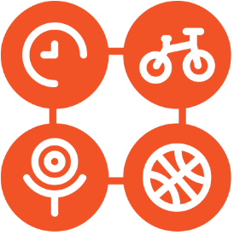 | I know how to separate from my main carer.  I know the nursery routines.  I know the names of some of my nursery friends.  I can pass an object around the circle (turn taking). | I know how to separate from my main carer.  I know the routines of my new class.  I know the names of my friends in my new class.  I can talk about what is special about me.  I can talk about how I am the same or different from my friends.

EYFS - Autumn 2
 | Nursery | Reception
Theme for learning/core books/rhymes and experiences | Sparkle and Shine  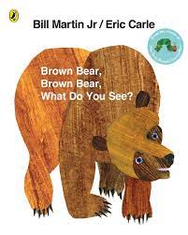  Twinkle Twinkle Little Star | Sparkle and Shine  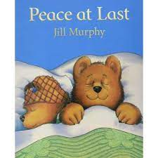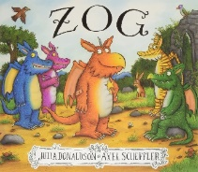
Suggested books linked to theme | 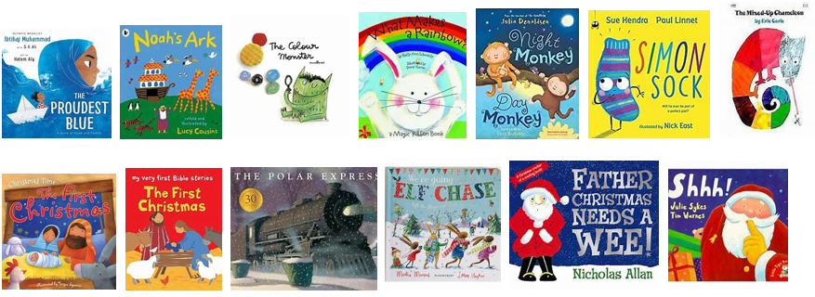
Theme days/ celebrations | 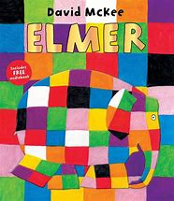  Anti-bullying Week:  I know different things I can do to be kind.  I can talk about why being kind is important.  I know ways in which I am the same or different to my friends.  I know it is okay to be different.
Personal, Social and Emotional Development | I know the rules in nursery.  I can take turns with resources.
Physical development | I am developing a comfortable pencil grip.  I know which hand I write or draw with (dominant hand).  I can draw circles, lines, zig-zags and spirals using mark making tools.  I can move safely around the outdoor area in different ways.  I can put on my own coat. | I am developing a comfortable pencil grip.  I know which hand I write or draw with (dominant hand).  I can draw circles, lines, zig-zags and spirals using mark making tools.  I can move safely around the outdoor area in different ways.  I can put on my own coat.

EYFS – Spring 1
 | Nursery | Reception
Theme for learning/core books/rhymes and experiences | Magical Storyland  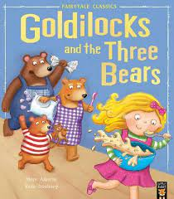  Incy Wincy Spider | Magical Storyland  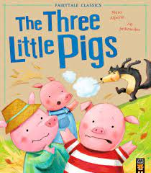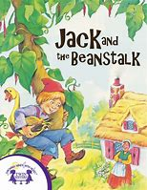
Suggested books linked to theme | 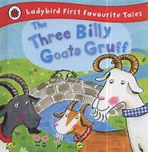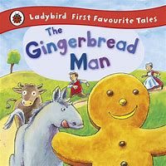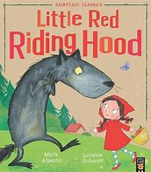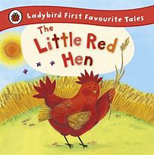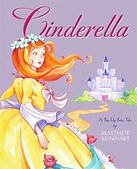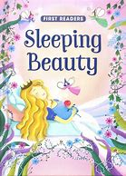
Theme days/ celebrations | 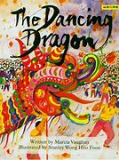  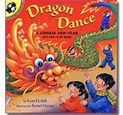  Chinese (Lunar) New Year  I know that Chinese New Year is a celebration.  I know some ways in which they celebrate:  (Dragon dancing, special meal, family time  I begin to understand that different people celebrate in different ways.  Chinese and Lunar New Year - CBeebies - BBC
Personal Social and Emotional Development |  | I can play cooperatively with others  I can join in with whole class games, taking turns  I know about consequences
Physical Development | I am beginning to show accuracy with throwing and catching a large ball.  I can go up steps and stairs, or climb up apparatus, using alternate feet.  I know how to one-handed tools and equipment- I can make snips in paper with scissors. | I can revise and refine the fundamental movement skills I have already acquired: • rolling • crawling • walking • jumping • running • hopping • skipping • climbing

EYFS – Spring 2
 | Nursery | Reception
Theme for learning/core books/rhymes and experiences | Amazing Animals  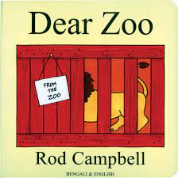  Old MacDonald Had a Farm | Amazing Animals  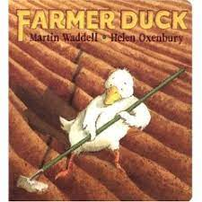
Suggested books linked to theme

Theme days/ celebrations | Holi  I know that Holi is the Hindu festival of colours.  I know some ways in with they celebrate Holi
Personal Social and Emotional Development |  | I can tell you how exercise makes me feel  I can tell you how some things are good for my health
Physical Development | I can skip, hop, stand on one leg and hold a pose for a game like musical statues.  I can balance and climb along different equipment and stepping stones.  I am beginning to hit a ball with a bat, sometimes with accuracy. | I can revise and refine the fundamental movement skills I have already acquired: • rolling • crawling • walking • jumping • running • hopping • skipping • climbing  I can use my core muscle strength to achieve a good posture when sitting at a table or sitting on the floor.

EYFS – Summer 1
 | Nursery | Reception
Theme for learning/core books/rhymes and experiences | Watch it Grow!  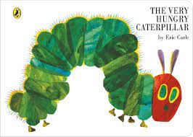  Mary Mary, Quite Contrary | Watch it Grow!  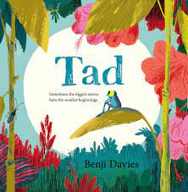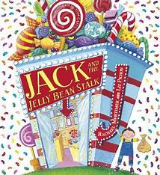
Suggested books linked to theme

Theme days/ celebrations | Ramadan/Eid  I know that Muslim’s fast during Ramadan.  I know some ways in which they celebrate Eid.  I know that different people celebrate in different ways.  Eid al-Fitr - CBeebies - BBC
Personal Social and Emotional Development | I know that fruit and vegetables are healthy foods. | I can control my behaviour in different situations.
Physical Development | I can ride a scooter and a balance bike.  I can move my body in response to different music as I dance.  I can thread beads onto a string.  I can manipulate small items eg pegs in a peg board, hammer and nails with the tap a shapes. | I can further develop and refine a range of ball skills including: throwing, catching, kicking, passing, batting, and aiming.  I can confidently and safely use a range of large and small apparatus indoors and outside, alone and in a group.  I can combine different movements with ease and fluency.

EYFS – Summer 1
 | Nursery | Reception
Theme for learning/core books/rhymes and experiences | Off We Go!  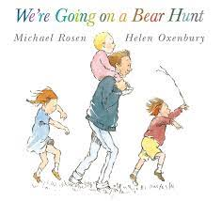  The Wheels on the Bus | Off we Go!  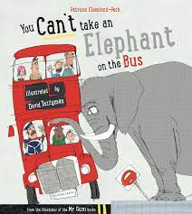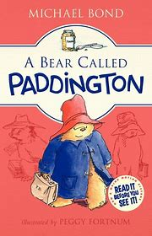
Suggested books linked to theme

Theme days/ celebrations | I know how to be safe when I am out of school on a trip.  I know how to cross the road safely with an adult- wait, stop, look, listen.
Personal Social and Emotional Development | I can finish a chosen activity.  I can wait a short time for attention from an adult.  I can take turns with the resources. | I can tell you what I need to improve.  I can work towards targets.  I respond to questions about ways I keep myself healthy (food/sleep/hygiene etc)  I can tell you ways I keep safe  I can keep going and persevere when things are tricky.
Physical Development | I can run, jump, hop and skip safely around a space.  I can use a comfortable grip with good control when holding pens and pencils.  I know how to zip up my coat and am sometimes successful. | I can use a range of tools competently, safely and confidently. Suggested tools: pencils for drawing and writing, paintbrushes, scissors, knives, forks and spoons.  I can develop confidence, competence, precision and accuracy when engaging in activities that involve a ball.  I have the foundations of a handwriting style which is fast, accurate and efficient.
Early Learning Goals | Personal, Social and Emotional  I can give focused attention to what my teacher says, responding appropriately, even when engaged in activity, and show an ability to follow instructions involving several ideas or actions.  I am confident to try new activities and show independence, resilience and perseverance in the face of challenge  I can explain the reasons for rules, know right from wrong and try to behave accordingly  I can work and play cooperatively and take turns with others
Physical Development
I can negotiate space and obstacles safely, with consideration for themselves and others
I can demonstrate strength, balance and coordination when playing
I can move energetically, such as running, jumping, dancing, hopping, skipping and climbing.
Ongoing learning opportunities for this subject within continuous provision

Y1
DELIVERY METHOD: ENRICHMENT/EXTRA-CURRICULAR OPPORTUNITIES: Delivered through weekly sessions taught by Sports Coach or/and class teacher. Each class is timetabled 2 hours of PE each week. Blocked activities during annual health and sports week.

OUTLINE OF TERMLY LEARNING THEMES – |  |  | NC CONTENT: CONTENT, KNOWLEDGE AND SKILLS  What pupils will be taught to do, know and understand |  | KEY VOCABULARY
AUTUMN 1  Games 1 (Year 1)  Dance 1 (Year 1)  Mindfulness (Year 1) | AUTUMN 2  Games 2 (Year 1)  Gymnastics 1 (Year 1)  Sleep (Year 1) |  | KS1  Master basic movements including running, jumping, throwing and catching, as well as developing balance, agility and co-ordination, and begin to apply these in a range of activities.  Participate in team games, developing simple tactics for attacking and defending. Perform dances using simple movement patterns. |  | Gymnastics:  Balance Copy, Entrance and exit, High, Low, Mirror, Points and patches, Points of contact, Roll, Shapes and positions, Stretch, Tall, Tension, Tip toes, Tuck shape, Wide, Arch, Core, Dish, Feet, Hands, Jump, Land, Low level shapes, Momentum, Over, Pike, Routine, Stomach, Straddle, Techniques, Through, Transfer, Travel, Tuck, Under, Weight, Apparatus, Benches, Control, Copying, Direction, Levels, Linking, Mirroring, Points, Safety, Timing  Athletics:  Aim, Bowl, Catch, Direct, Distance, Driving, Javelin, Relay, Run, Sprint, Strong leg, Target, Throw  Dance:  Phrase, Gesture, Pathways, Energy, Weight, Recall, Rehearse, Refine, Command, Travelling, Motif, Movement  Games:  Accuracy, Aiming, Balance, Bouncing, Catching, Change direction, Control, Handling, Pathways, Receiving, Rolling, Sending, Space, Stop, Target, Throwing, Underarm, Direction, Dribbling, Hitting, Kicking, Losing, Passing, Points, Racket face, Rebound, Sideways, Stopping, Striking, Teamwork, Winning, Attackers, Attacking, Communicating, Defenders, Defending, Dodging, Eye contact, Intercepting, Marking, Mirroring, Scoring, Side-step, Space, Tactics, Team, Backwards, Dribbling, Football, Forwards, Inside of foot, Rugby, Sideways, Tagging, Try scoring, Try, Circuits, Continuous, Core muscles, Exercise, Fitness, Games, Heart rate, Intensity, Jumping Jacks, Jumps, Motor skills, Mountain climbers, Reactions, Recovery, Relay races, Shuttle run, Speed  Mindfulness:  Attention, Breathe, Lungs, Mindfulness, Noticing, Relax, Visualisation exercise  Sleep:  Routine, Sleep  Nutrition:  Balanced diet, Carbohydrates, Dairy, Food groups, Healthy lifestyle, Nutrition  Teamwork and Leadership:  Communication, Encouragement, Problem solving, Teamwork, Verbal  Personal Care:  Bacteria, Confidence, Decay, Dental, Gums, Mouth, Personal care, Plaque, Self-care, Teeth, Toothbrush, Toothpaste  Yoga:  Balance, Body-weight, Breath, Chest, Hips, Lungs, Nostril, Poses, Relax, Ribs, Spine, Squat, Torso
SPRING 1  Games 3 (Year 1)  Dance 2 (Year 1)  Nutrition (Year 1) | SPRING 2  Games 4 (Year 1)  Gymnastics 2 (Year 1)  Teamwork and Leadership (Year 1)
SUMMER 1  Games 5 (Year 1)  Dance 3 (Year 1)  Personal Care (Year 1) | SUMMER 2  Athletics  Gymnastics 3 (Year 1)  Yoga (Year 1)
LEARNING OUTCOMES:
Gymnastics  Explore and use space effectively using agility, balance and coordination skills.  Balance using different parts of the body, exploring points and patches (Beginning to on apparatus).  To take weight on hands and feet.  Learn copy and name basic and advanced low-level shapes.  Link shapes and rolls to form a short sequence.  Explore different styles of travelling: under, over and through. Beginning to travel on apparatus.  Jump and land safely, whilst exploring different jumping techniques.  Copy, mirror and create a small routine and matching actions. |  | Athletics  Run fast from a standing start developing speed and coordination.  Jump and throw, developing coordination, agility and rhythm.  Run and kick for accuracy and speed.  Basic throw, catch and skip developing hand-eye coordination and ball handling and throwing skills.  Basic bowl and step throwing with agility and with skill. |  | Dance  Create a class performance.  Select and use a variety of movements to form a short dance phrase.  Perform a variety of movements to form a group dance phrase.  Explore a range of movements. |  | Games  Develop spatial awareness whilst moving in different directions.  Show control and balance in basic movements.  Carry and balance equipment whilst changing speed and direction  Move in different directions whilst handling a ball.  Develop control and accuracy when rolling a ball.  Underarm throw with control and accuracy.  Show control and accuracy when throwing and aiming.  Gain rhythm when throwing and striking a ball.  Strike and kick a moving ball with accuracy and control.  Engage in team games.  Develop spatial awareness whilst moving in different directions.  Show control and balance in basic movements.  Send and receive a bouncing ball whist positioning body correctly.  Understand the concept of dribbling and the skills required.  Strike and kick a moving ball with accuracy and control.  Demonstrate the dribbling skills required for football.  Demonstrate the passing skills required for football.  Demonstrate the shooting skills required for football.  Familiarise and understand the passing/movements required in rugby.  Develop the skill of tagging an opponent in rugby.  Engage in team games.  Understand what attacking and defending is using simple practices and demonstrate this.
CONCEPTUAL LINKS ACROSS THE CURRICULUM:

Y2, Y2/3, Y3
DELIVERY METHOD: ENRICHMENT/EXTRA-CURRICULAR OPPORTUNITIES: Delivered through weekly sessions taught by Sports Coach or/and class teacher. Each class is timetabled 2 hours of PE each week. Blocked activities during annual health and sports week.
OUTLINE OF TERMLY LEARNING THEMES – |  |  |  | NC CONTENT: CONTENT, KNOWLEDGE AND SKILLS  What pupils will be taught to do, know and understand |  | KEY VOCABULARY
YEAR A: |  |  |  | KS1  Master basic movements including running, jumping, throwing and catching, as well as developing balance, agility and co-ordination, and begin to apply these in a range of activities  Participate in team games, developing simple tactics for attacking and defending  Perform dances using simple movement patterns.  KS2  Use running, jumping, throwing and catching in isolation and in combination  Play competitive games, modified where appropriate [for example, badminton, basketball, cricket, football, hockey, netball, rounders and tennis], and apply basic principles suitable for attacking and defending.  Develop flexibility, strength, technique, control and balance (for example, through athletics and gymnastics).  Perform dances using a range of movement patterns.  Take part in outdoor and adventurous activity challenges both individually and within a team.  Compare their performances with previous ones and demonstrate improvement to achieve their personal best. |  | Year 2:  Gymnastics:  Arch, Balance, Control, Dish, Entrance and exit, Linking, Mirroring, Pike, Straddle, Tuck, Velocity, Apparatus, Egg roll/tuck roll, Jumping, Landing, Log roll, Low level shape, Medium level shape, Pencil and star shapes, Shoulder roll, Teddy bear roll, Bend knees, Direction, Dynamic, Front support, Height, Level, Pencil, Point and patches, Rolls, Routine, Sequence, Shapes, Star, Still, Straight, Tensing, Travel, Turns  Athletics:  Aiming, Balance, Baton, Clearing, Consistency, Control, Distance, Endurance, Height, Hurdles, Long jump, Momentum, Non-throwing arm, Obstacles, Overarm, Power, Recovery, Relay race, Rolling, Shuttle Run, Speed, Sprinting, Strides, Targets, Triple jump  Dance:  Dynamic, Mirroring, Pathway, Phrase, Recall, Refine, Rehearse, Shapes, Space, Tempo, Animation, Rhythm, Unison, Canon, Motif, Movement, Travelling  Games:  Balancing, Body behind the ball, Bouncing, Carrying, Catching, Chasing, Collecting, Control, Counter balance, Dribbling, Handling, Intercept, Movement, Pathways, Possession, Receiving, Rolling, Sending, Space, Spatial awareness, Stopping, Throwing, Underarm, Aiming, Backhand, Control, Court, Fielding, Forehand, Gathering, Grip, Inside of foot, Kicking, Long barrier, Overarm, Racket, Side-on, Sole of foot, Striking, Target, Teamwork, Attacking, Defending, Dodging, Football, Invasion game, Marking, Overhead, Passing, Points, Shooting, Target, Attacking, Basketball, Defenders, Hockey, Hockey sticks, Opponent, Scoring, S Trapping, Travelling, Accuracy, Chipping, Club, Competition, Course, Distance, Fairway, Flight, Putting, Safety, Swing, Tee, Tick-tock, Tri-golf  Mindfulness:  Attention, Breathe, Caring, Flavour, Focus, Gratitude, Mind jar, Mindful, Mindfulness, Mindless, Nose/mouth, Notice/Noticing, Positive thoughts, Saliva, Sensations, Taste, Texture, Visualisation exercise, Visualise  Sleep:  Routine, Sleep  Nutrition:  Balanced diet, Calorie, Free sugar, Natural sugar content  Teamwork and Leadership:  Communication, Cooperation, Encouragement, Listening, Problem solving, Strengths, Support, Teamwork, Verbal  Personal Care:  Bacteria, Body odour, Confidence, Germs, Hygiene, Self-esteem  Yoga:  Balance, Body-weight, Breath, Chest, Cooperation, Hips, Lungs, Nostril, Partnership, Poses, Relax, Ribs, Spine, Squat, Support, Thigh, Torso, Waist |  | Year 3:  Gymnastics:  Apparatus, Arch, Back support, Balance, Contrast, Control, Dish, Entrance and exit, Flight, Fluidity, Front support, Linking, Low level shape, Medium level shape, Mirroring, Pike, Rolling, Safety, Straddle, Tuck, Weight, Bent knees, Core, Forward roll, Matching, Soft knees, Speed, Spin, Strength, Support, Turn, Twist, Cat leap, Dismount, Full turn, Half turn, Height, Jumping, Landing, Level, Pathway, Rebound, Roll, Routine, Squat, Step, Synchronization, Travelling, Vault  Athletics:  Drive, Heave, Hurdle, Jump, Lead leg, Leap, Pull, Push, Rhythm, Run, Sling weight transfer, Standing long jump, Standing start  Dance:  Canon, Choreographic, Phrase, Stance, Agility, Co-ordination, Gesture, Pathway, Phase, Counts, Direction, Down stage, Dynamics, Extension, Fluid/Fluency, Genre, Levels, Musicality, Pace, Performance, Sequence/Sequencing, Structure, Turns, Unison  Games:  Bat, Bowl, Catch, Cricket, Defensive, Drive, Field, Long barrier, Overarm, Shot, Stance, Throw, Two handed, Underarm, Wickets, Accuracy, Control, Dribble, Goalkeeper, Inside (of the foot), Move, Outside (of the foot), Pass, Run, Shoot, Turn, Accurate, Aim, Awareness, Balanced, Intercept, Receive, Score, Stance, Tackle, ‘W’ Shape, Bounce, Centre, Chest pass, Dodge, Feeder, Footwork, Goal attack/defence/keeper/shooter, Landing foot, Mark, Non-shooting hand, One-step, Overhead, Pass, Pivot, Positions, Power, Shoot, Step in, Technique, Throw, Wing attack/defence, Zones, Backwards, Ball and collision, Collision, Evade, Forwards, Passing, Receiver, Rugby, Sidestep, Sideways, Speed and run, Tag, Try  Mindfulness:  Attention, Breathe, Calm, Caring, Exhale, Grateful, Gratitude, Inhale, Lungs, Mindful, Mindfulness, Mouth, Nose, Notice/Noticing, Positive thoughts, Thankful, Visualise, Visualisation exercise,  Sleep:  Caffeine, Hormone, Melatonin  Nutrition:  Macro-nutrients, Micro-nutrients, Minerals, Non-organic, Organic, Vitamins  Teamwork and Leadership:  Cooperation, Delegating, Directing, Goals, Leadership, Listening skills, Skills, Teamwork  Personal Care:  Mental health, Physical health, Self-confidence, Self-esteem, Wellbeing  Yoga:  Abdominals, Balance, Breath, Cooperation, Exhale, Inhale, Massage, Partnership, Poses, Spine, Support, Temple, Thigh, Waist
AUTUMN 1  Games 1 (Year 2)  Dance 1 (Year 2)  Mindfulness (Year 2) | SPRING 1  Games 3 (Year 2)  Dance 3 (Year 2)  Sleep (Year 2) | SUMMER 1  Games 5 (Year 2)  Dance 2 (Year 3)  Nutrition (Year 2)
AUTUMN 2  Games 2 (Year 2)  Dance 2 (Year 2)  Mindfulness (Year 3) | SPRING 2  Games 4 (Year 2)  Dance 1 (Year 3)  Sleep (Year 3) | SUMMER 2  Athletics (Year 2)  Dance 3 (Year 3)  Nutrition (Year 3)
YEAR B:
AUTUMN 1  Football (Year 3)  Gymnastics 1 (Year 2)  Teamwork and Leadership (Year 2) | SPRING 1  Hockey (Year 3)  Gymnastics 3 (Year 2)  Personal Care (Year 2) | SUMMER 1  Cricket (Year 3)  Gymnastics 2 (Year 3)  Yoga (Year 2)
AUTUMN 2  Tag Rugby (Year 3)  Gymnastics 2 (Year 2)  Teamwork and Leadership (Year 3) | SPRING 2  Netball (Year 3)  Gymnastics 1 (Year 3)  Personal Care (Year 3) | SUMMER 2  Athletics (Year 3)  Gymnastics 3 (Year 3)  Yoga (Year 3)
LEARNING OUTCOMES:
Gymnastics  YEAR 2:  Explore medium level shapes with linking, mirroring and balances.  Compare and contrast low and medium level shapes with confidence and rehearse them.  Roll safely using a variety of rolling techniques. Incorporate two shapes into a sequence.  Perform low level shapes with some precision and perform shapes in flight.  Use apparatus (extended) safely with entrances, exits, balances and including medium level shapes.  Jump and land safely using apparatus, including from a variety of heights, directions and landings.  Model linking and mirroring of low-level shapes. Including balancing & travel with a partner using mirroring technique  YEAR 3:  Perform short sequence with: low and medium level shapes; with matching and mirroring; contrasting shapes with some linking.  Take weight confidently on hands (developing core strength) and roll safely, exploring different rolling methods (Front and backward Rolls).  Perform a wide range of shapes and balances on apparatus.  Perform shapes in flight, on and off a piece of apparatus, including turn, twist and spin.  Perform a range of jumps and leaps from varying heights and on a vault.  Perform mirrored and matching travels and balances with a partner. |  |  | Athletics  YEAR 2:  Developing awareness of speed when running a short distance, including control and fluency in movements; understanding how their body reacts when running.  Jump for distance. Developing awareness of space, height and distance.  Adjust and make changes to running speed when completing different distances.  Throw and aim with accuracy towards a given target.  Choose the best way to throw different pieces of equipment dependent on size & weight.  YEAR 3:  Run a relay and change over the baton appropriately – including passing a baton from standing start.  Jump for distance including jumping from a standing start. Developing skills to jump further distances. *Learn basics of hurdling, keeping head same height throughout jumping.  Run for speed, including over longer distances. *Learn basics of hurdling, keeping head same height throughout jumping.  Developing throwing skills – further distances and a range of techniques. |  | Dance  YEAR 2:  Create a class performance and observe others work and give feedback using simple dance vocabulary.  Select and explore an air pattern, jump and shape to form a short dance phrase.  Work as a group to recall choreography, rehearse and refine ideas.  Perform a variety of movements to form a group dance phrase; exploring turning, rotation, circular shapes/ dynamic through movement.  Explore movements considering size of movements, tempo, dynamics, floor pattern, air pattern, levels and shape.  YEAR 3:  Organising sections of dances to create one piece, working in sync with other group members.  Assess others’ work.  Work as a group to select learnt positions and movements to create short dance phrases.  Use choreographic devices to enhance dance phrases, including choregraphing a solo.  Select and explore a variety of movements, responding imaginatively to a range of stimuli.  Perform movement actions individually, with partners, a group and whole class.  Explore, repeat and link a range of actions with coordination and memorise.  Respond to a beat, using music as a stimulus to influence dance. |  | Games  YEAR 2:  Maintain balance whilst reacting quickly to commands.  Perform underarm and overarm throwing with control.  Demonstrate a range of striking and gathering skills, including into a small game.  Demonstrate confidence in ball handling skills.  Control a moving ball in a variety of ways.  Show rolling and gathering skills with confidence and precision.  Show progression from rolling into catching and throwing.  Attack & defend in a game, making and denying space.  Throw & catch to pass and receive a ball in a game.  Control a moving ball in a variety of ways. Perform kicking skills with control and accuracy.  Use space whilst passing and receiving a kicked ball.  Understand the basics of holding a hockey stick and dribbling a ball.  Pass a hockey ball to a partner and group with control.  Demonstrate attacking skills in hockey such as shooting.  Demonstrate bouncing a basketball with control.  Develop bouncing skills into dribbling activities.  Move away from a defender whilst continuing to dribble.  Show progression from rolling into catching and throwing.  Develop tactics when shooting at and protecting targets.  Attack & defend in a game, making and denying space.  Throw & catch to pass and receive a ball in a game.  YEAR 3:  Cricket  Bat correctly  Catch correctly.  Accurately bowl under and overarm using appropriate technique.  Use different batting shots.  Field using appropriate techniques.  Football  Control the ball, dribble and turn.  Pass the ball accurately and control the ball when receiving a pass including whilst on the move.  Shoot and play the position of a goalkeeper.  Apply learnt skills in a game.  Hockey  Hold the stick and dribble under pressure. Pass and receive the ball with improving accuracy.  Tackle correctly.  Shoot with accuracy.  Play hockey in a game situation.  Tag Rugby  Evade and tag opponents while keeping control of the rugby ball.  Pass the ball accurately and receive the ball safely including whilst on the move and in a game situation  Apply learnt skills in a game of rugby.
CONCEPTUAL LINKS ACROSS THE CURRICULUM:

Y4, Y4/5, Y5
DELIVERY METHOD: ENRICHMENT/EXTRA-CURRICULAR OPPORTUNITIES: Delivered through weekly sessions taught by Sports Coach or/and class teacher. Each class is timetabled 2 hours of PE each week. Blocked activities during annual health and sports week.
OUTLINE OF TERMLY LEARNING THEMES – |  |  |  | NC CONTENT: CONTENT, KNOWLEDGE AND SKILLS  What pupils will be taught to do, know and understand |  | KEY VOCABULARY
YEAR A: |  |  |  | KS2  Use running, jumping, throwing and catching in isolation and in combination  Play competitive games, modified where appropriate [for example, badminton, basketball, cricket, football, hockey, netball, rounders and tennis], and apply basic principles suitable for attacking and defending.  Develop flexibility, strength, technique, control and balance (for example, through athletics and gymnastics).  Perform dances using a range of movement patterns.  Take part in outdoor and adventurous activity challenges both individually and within a team.  Compare their performances with previous ones and demonstrate improvement to achieve their personal best. |  | Year 4:  Gymnastics:  Apparatus, Balances, Contrast, Entrance and exit, Fluency, Front support, Low level shape, Medium level shape, Points of contact, Routing, Tension, Transition, Travelling, Abdominal, Arabesque, Arch, Dish, Forward roll, Headstand, Pike, Rolling, Shoulder stand, Straddle, Support, Tension, Tuck, Weight , Assessment, Cat leap, Chassis step, Communication, Control, Flow, Hop, Jumping, Linking, Mirroring and matching, Pathways, Pivot, Rolling, Routing, Shapes, Synchronisation, Timing, Turning, Yoga  Athletics:  Assessment, Changeover, Communication, Discus, Fling, Hammer, Heats, Javelin, Maintaining pace, Relays, Scissor jump, Shot put, Speed bounce, Sprint finish, Sprinting, Teamwork, Technique, Vertical jump  Dance:  Archway, Bollywood, Cannon, Dynamics, Footwork, Gesture, Narrative, Levels, Pathway, Phrase, Ballet, Charleston, Co-ordinate, Counts of 8, Hand jive, Jive, Lift, Pace, Rhythm, Rock n roll, Sequence, Swing, Timing, Transition, Turns, Unison  Games:  Accuracy, Baseline, Bounce, Bounce pass, Catch, Chest pass, Dribble, Double Dribble, Head, Opponent, Pass, Pivot, Protect, Receive, Sideling, Sprint, Target, Aim, Overhead pass, Shoot, Space, Throw, Backstop, , Bat, Batting, Bowl/bowling, Game. Hands, Hit, Overarm, Rounders, Thorw/Throwing, Underarm, Waist height, Backhand, Forehand, Hit, Move, Position, Ready position, Serve, Smash  Mindfulness:  Breathe, Calm, Concentration, Emotions, Exhale, Feelings, Focus, Inhale, Mind jar, Mindful walking, Mindfulness, Mind’s eye, Visualisation, Visualise  Sleep:  Routine, Sleep, Setting  Nutrition:  Energy, Calorie, Fats  Teamwork and Leadership:  Cooperation, Improvisation, Listening skills, Teamwork, Trust  Personal Care:  Angry, Confident, Conflict, Confused, Content/satisfied, Determines, Embarrassed, Emotions, Excited, Feelings, Frustrated, Happy, Lonely, Nervous/anxious, Pessimistic, Proud, Sad, Scared, Shy, Surprised, Tired, Unsure  Yoga:  Abdominal, Balance, Calf, Cooperation, Exhale, Inhale, Massage, Partnership, Pelvis, Rotate, Sacrum, Spine, Strength, Support, Temple, Thigh, Waist |  | Year 5:  Gymnastics:  Abdominals, Cat springs, Caterpillar walks, Core strength, Entrance and exit, Flight, Fluidity, Front support, Low level, Medium level, Narrow, Partner sequence, Performances, Pike, Reach, Rolling, Squat, Straddle, Stretch, Thrust, Tuck shape, Vault, Weight on hands, Wide, Aligned body, Apparatus, Balance, Bound, Control, Crash mat, Extend, Headstand, Points of contact, Rolling, Rounded back, Routing, Sequence, Spring board, Squat, Transition, Vaulting horse, Weight  Athletics:  Baton, Change, Chest pass, Drive, Lead, Pull pass, Shoulder pass, Skip, Trail  Dance:  Cannon, Gesture, Haka, Phrase, Repetition, Choreographed, Level, Mirroring, Musicality, Pathways, Phrase, Popping, Sequence, Stance, Transition, Unison, Variation, Balancing, Direction, Floor plan, Freeze frame, Improvisation, Staging, Tempo, Travelling  Games:  Accuracy, Aiming, Batting technique, Crease, Cricket Stance, Fielding, Figure of six, Grip and stance, High throw/low throw, Lofted Drive, Near/Middle/Far, Overarm, Underarm, Wicket keeper, Control, Defend, Mark, Receive (pass), Shoot, Speed, Tackle, Turn, Aim, Awareness, Dribble, Head, Intercept, Mark, Move, Pass, Possession, Power, Space, Target, Bean bag, Bounce, Catch, Chest, Hoops, Overhead, Pivot, Rope ladders, Strategy, Tactics, Attack, Attacker, Backwards, Catch, Defender, Direction, Evade, Forward, Jog, Movement, Receive, Sidestep, Sprint, Tag  Mindfulness:  Attention, Calm, Caring, Compromise, Concentration, Connections, Consideration, Cooperation, Details, Emotions, Focus, Gratitude, Mindfulness, Neurons, Noticing, Positive thoughts, Silence, Visualisation  Sleep:  Night terror, Paralysis, REM sleep, Sleep stages  Nutrition:  Balance, Menu, Planner, Recipe  Teamwork and Leadership:  Assertive, Confidence, Leader, Leadership, Personality  Personal Care:  Fixed mindset, Growth mindset, Mindset, Resilience  Yoga:  Abdominal muscles, Abdominal, Balance, Calf, Cooperation, Exhale, Inhale, Partnership, Sacrum, Shin, Spine, Strength, Support, Thigh, Waist
AUTUMN 1  Basketball (Year 4)  Dance 1 (Year 4)  Mindfulness (Year 4) | SPRING 1  Tennis (Year 4)  Dance 3 (Year 4)  Sleep (Year 4) | SUMMER 1  Rounders (Year 4)  Dance 2 (Year 5)  Nutrition (Year 4)
AUTUMN 2  Handball (Year 4)  Dance 2 (Year 4)  Mindfulness (Year 5) | SPRING 2  Dance 1 (Year 5)  Sleep (Year 5) | SUMMER 2  Athletics (Year 4)  Dance 3 (Year 5)  Nutrition (Year 5)
YEAR B:
AUTUMN 1  Football (Year 5)  Gymnastics 1 (Year 4)  Teamwork and Leadership (Year 4) | SPRING 1  Hockey (Year 5)  Gymnastics 3 (Year 4)  Personal Care (Year 4) | SUMMER 1  Cricket (Year 5)  Gymnastics 2 (Year 5)  Yoga (Year 4)
AUTUMN 2  Tag Rugby (Year 5)  Gymnastics 2 (Year 4)  Teamwork and Leadership (Year 5) | SPRING 2  Netball (Year 5)  Gymnastics 1 (Year 5)  Personal Care (Year 5) | SUMMER 2  Athletics (Year 5)  Gymnastics 3 (Year 5)  Yoga (Year 5)
LEARNING OUTCOMES:
Gymnastics  Year 4:  Perform & evaluate a routine: matching balances & stands; with matching balances on apparatus; with contrasting balances; with contrasting balances on and over apparatus; with linked balances on and over apparatus.  Perform a shoulder and headstand safely without support.  Perform a forward roll with appropriate entrances and exits including on, off and over apparatus.  Link movements by performing jumps, turns and pivots.  Complete mirroring actions along different pathways and levels, including basic rolls.  Year 5:  Perform a range of routines with rolling; including jumping rolls, build into rolling from and into a pike position. Perform both a stag jump and a split leap. Progress from a cartwheel to a perform a round-off. Perform Cat Springs.  Perform forwards and backward rolls with a range of entrances and exits. Learning a headstand, transitioning into a forward roll and incorporating as part of a routine.  Vault safely with a range of entrances and exits and then into rolling, building up to various landings on and over a vault.  Plan a sequence of movements on apparatus both individually and as a group, in time with each other to form a routine. |  |  | Athletics  Year 4:  Communicate as a team to make relay changeovers. Improving running technique including the sprint finish and maintaining sprint pace.  Can challenge self to jump for distance including measuring performance. Jumping for height including high over obstacles.  Sprinting, challenge self and recording performance.  Throw for distance challenging self and recording performance. Using overhead heave and fling throw.  Year 5:  To run relays, running in a given zone, changing baton over with increased skill.  Develop jumping for distance (triple jump); jumping in different ways and competing competitively.  Develop running for speed including sprint from a start finish and sprinting further distance over a given time. Developing hurdling skills, including the role of the lead and trail leg; applying skill to competitive situation.  Develop throwing skills using a variety of techniques. Throwing javelin from a standing start. |  | Dance  Year 4:  Developing dance when creating one piece, performing in unison and sync with other group members in front of the class.  Self- assess and assess peers’ work, and give feedback using appropriate dance vocabulary.  Developing synchronisation when working in a group including to different rhythms.  Respond to teacher instruction to create a choreographed dance routine.  Developing choreographic skill incorporating more free – creative thinking.  Developing good co-ordination within a sequence of movements.  Movements articulate the style of dance well.  Use music to influence movement with increasing skill.  Year 5:  Learn, rehearse and perform choreographed dance phrases of increasing complexity.  Self-assess and assess others’ work and give critical feedback using appropriate vocabulary.  Create versatile movements within a dance sequence including a range of directions.  Choreograph a sequence of movements that use contact between two or more people.  Use a range of dance techniques to develop their movements.  Develop movements to incorporate at least one lift in a sequence of movements.  Identify floor plans and use within their movements, including starting and finishing area. |  | Games  By the end of this phase:  Rounders  Throw at others and a target under pressure.  Catch consistently under pressure.  Strike a stationary ball demonstrating correct grip.  Develop fielding techniques.  Tennis  Demonstrate the ready position and react to ball direction, including correct position to attempt shot.  Play a simple forehand and backhand shot.  Simulate the throw of a serve.  Move and catch the ball correctly applied to the layout of a court.  Throw the ball with accuracy when on a court.  Handball  Throw and catch using different techniques.  Pass and shoot the ball accurately and within a competitive situation.  Dribble with ball and make a pass.  Move using space appropriately.  Basketball  Dribble under pressure.  Pass & catch a basketball using chest bounce, developing to doing so whilst on move.  Pivot to take, receive and make pass.  Cricket  Developed over and underarm bowling applied to game.  Improving accuracy of batting.  Developing deep field catching – catching ball at varying heights.  Developing the lofted drive.  Football  Control the ball, keeping it close.  Developing passing skills including developed use of inside of the foot.  Able to perform block tackle and mark effectively.  Turn and shoot at speed and with accuracy.  Application of skills within game.  Hockey  Use correct technique dribbling.  Pass & receive – using space; appropriate skills to keep possession.  Shoot with power and developed accuracy.  Tackle and mark.  Netball  Pass, Pivot pass, shoot & throw with accuracy, including chest, bounce and overhead.  Use tactics for game dominance, building on dodge and marking.  Develop footwork.  Play to rules.  Tag Rugby  Evade and tag opponents running at speed, changing direction and developing control.  Pass & receive at speed in game situation.  Refine attacking and defending skills.  Develop team tactics.
CONCEPTUAL LINKS ACROSS THE CURRICULUM:

Y6
DELIVERY METHOD: ENRICHMENT/EXTRA-CURRICULAR OPPORTUNITIES: Delivered through weekly sessions taught by Sports Coach or/and class teacher. Each class is timetabled 2 hours of PE each week. Blocked activities during annual health and sports week.
OUTLINE OF TERMLY LEARNING THEMES – |  |  | NC CONTENT: CONTENT, KNOWLEDGE AND SKILLS  What pupils will be taught to do, know and understand |  | KEY VOCABULARY
AUTUMN 1  Basketball (Year 6)  Dance 1 (Year 6)  Mindfulness (Year 6) | AUTUMN 2  Handball (Year 6)  Gymnastics 1 (Year 6)  Sleep (Year 6) |  | KS2  Use running, jumping, throwing and catching in isolation and in combination  Play competitive games, modified where appropriate [for example, badminton, basketball, cricket, football, hockey, netball, rounders and tennis], and apply basic principles suitable for attacking and defending.  Develop flexibility, strength, technique, control and balance (for example, through athletics and gymnastics).  Perform dances using a range of movement patterns.  Take part in outdoor and adventurous activity challenges both individually and within a team.  Compare their performances with previous ones and demonstrate improvement to achieve their personal best. |  | Gymnastics:  Apparatus, Balance, Body parts, Collaboration, Control, Counter balance, Counter tension, Entrance and exit, Fluidity, Headstand, Linking, Low, medium and high level, Points of contact, Pull, Push, Rolling, Shoulder stand, Tuck, Cartwheel, Weight on hands, Donkey kicks, Bunny hops, Hips, Tuck, Lean and non-lead, Plant, Start position, Star shape, Unison, Cannon, Handstand, Wight on hands  Athletics:  Cricket throw, Endurance, High jump , Long distance , Scissor kick , Strides, Sustaining, Track & Field, Vertical jump  Dance:  Canon, Gesture, Instrumentation, Parkour, Pathway, Phrase, Retrograde, Co-ordination, Level, Unison, Contact work, Core, Dynamics, Extension, Floor plan, Fluency, Improvisation, In the round, Musicality, Pace, Rhythm, Sequencing, Space, Tempo, Timing, Transitions  Games:  Aim, Accuracy, Arc, Balance, Bounce pass, Chest Pass, Defend, Dribble, Intercept, Mark, Opponent, Pass, Push, Space, Shoot, Strong, Target, Wide, Block, Score, 1st base only, Attack, Backstop, Bases, Batting box, Cupped hands, fingers pointing down, and soft hands, Deep fielding, half rounder, High-to-high, Long barrier, No ball, Out at 1st base, Out at base, Overarm, Rounder scored, Underarm, Wide ball, Backhand, Catch, Diagonal, Forehand, Overarm, Points, Rally, Ready position, Return, Serve, Smash, Underarm  Mindfulness:  Attention, Brain, Calm, Emotions, Exhale, Flavour, Focus, Hemisphere, Inhale, Lobes, Mind jar, Mindful, Mindfulness, Mindless, Neurobiology, Neuroplasticity, Notice, Noticing, Saliva, Sensations, Taste, Texture  Sleep:  Circadian rhythm, Insomnia, Puberty, Sleep disorders, Sleep routine  Nutrition:  Advertisement, Persuasion, Techniques  Teamwork and Leadership:  Collate, Delegate, Evidence, Organise, Teamwork  Personal Care:  Influence, Media, Negative, Positive, Self-image, Social media, Vloggers  Yoga:  Abdominals, Contact, Cooperation, Core, Diaphragm, Exhale, Expand, Hips, Inhale, Spine, Visualization
SPRING 1  Tennis (Year 6)  Dance 2 (Year 6)  Nutrition (Year 6) | SPRING 2  Outdoor and Adventure (Year 6)  Gymnastics 2 (Year 6)  Teamwork and Leadership (Year 6)
SUMMER 1  Rounders (Year 6)  Dance 3 (Year 6)  Personal Care (Year 6) | SUMMER 2  Athletics (Year 6)  Gymnastics 3 (Year 6)  Yoga (Year 6)
LEARNING OUTCOMES:
Gymnastics  Incorporate stands into cannon and or unison performances. Perform rotation, balances and stands in unison and cannon.  Perform shoulder, headstands, cartwheels and handstands safely without support.  Perform to roll on, off and over apparatus within routines. Include counterbalances and counter tension balances.  Roll in sequences on, off and over apparatus. Include into partner routines.  Combine balancing & travelling to produce a floor routine including matching. Incorporate apparatus. Produce mirroring routine with a partner on apparatus. |  | Athletics  Compete in a variety of athletics type races; adjusting running styles from sprinting to long distance.  Use correct techniques for all jumps, challenging self to jump further distances.  Run with greater fluency & speed, including hurdling; using the correct stride pattern. Can analyse the changes in speeds when sprinting and hurdling.  Use correct techniques for all throws, measuring accurately, challenging to throw further distances. |  | Dance  Perform choreographed dance narrative, improving movements, developing timing and spacing.  Asses self and others with increasing critical feedback and suggested actions for improvement using apt and precise language.  Explore and link a number of movements and patters.  *Use choreographed movements and patterns to tell a narrative; adapt movements in a more creative style; utilise a floor plan.  *Use choreographed movements and patterns to tell a narrative; adapt movements in a more creative style; utilise a floor plan.  Use gymnastic equipment to create improvised movement.  Allow different parts of the body to lead and influence the rest of the movement; using a range of levels tempos, and contact work. |  | Games  Rounders  Throw and catch a ball at varying heights consistently.  Strike a bowled ball consistently into different spaces.  Stop a moving ball consistently. Use the long barrier technique.  Apply apt strategies when fielding.  Compete in a full rounders game with understanding of rules.  Tennis  Show developing control of the ball.  Play forehand and backhand shot with increased confidence and accuracy.  Serve accurately underarm and overarm. Return serves.  Take correct positions on a court.  Play strategically aiming for points.  Handball  Developing dribbling and shooting within game situations.  Accurately pass a ball and intercept a pass.  Defend in game situations.  Demonstrate goalkeeper skills.  Apply skills to a full game situation.  Basketball  Shoot with the correct technique at end of a dribble.  Defend using defensive stance & mark.  Develop accuracy of pivot to take receive and make pass.  Apply skills to full size game.
CONCEPTUAL LINKS ACROSS THE CURRICULUM:

